**DATA BASE MANAGEMENT SYSTEM**

**Course Code: UE19CS301**



**Department of Computer Science Engineering**

**PES University**

**TEAM NUMBER: 11**

**TEAM MEMBERS:**

BALAJI B V: PES2UG19CS079

BALENDRA D.P: PES2UG19CS100

BHARAT KUMAR NAIK: PES2UG19CS086

**Faculty:** Prof. Nivedita Kasturi

**SQL- RAILWAY RESERVATION SYSTEM**

**DATA MODEL**: RDBMS

**DBMS CHOSEN**: PostgreSQL

PostgreSQL is an advanced, enterprise-class, and open-source relational database system. PostgreSQL supports both SQL (relational) and JSON (non-relational) querying.

Reasons for choosing PostgreSQL:

* It provides many features; Such as user defined types, Foreign key referential integrity, Views, Rules and Subquery.
* SQL stores information in the data tables, Which is less attractive yet it minimizes the possibility of errors.
* This provides good security and reliability.
* It handles concurrency better than the NOSQL.
* It supports all needed data types like documents, structures etc…
* It has powerful indexing methods and also provides Parallelization of read queries.
* PostgreSQL also provides major features like “assertion and triggers”.
* It is most widely used DBMS. Many companies use’s this DBMS such as Apple, Cisco, Instagram and Red hat etc…

RAILWAY RESERVATION SYSTEM

>>>>>>>>>>>>>>>>>>>>CREATE TABLE(8 Tables)<<<<<<<<<<<<<<<<<<<<

CREATE TABLE Train ( train_no int not null primary key tname varchar(32) , total_seats int not null , available_seats int not null );

CREATE TABLE Employee ( salary int not null , phone_no int not null , gender varchar(8) not null , fname varchar(32) not null, lname varchar(32), address varchar(64) , eid int not null primary key, dob date not null);

CREATE TABLE Passenger ( fname varchar(32) not null, lname varchar(32), address varchar(64) , pid int not null primary key, dob date not null , phone_no varchar(10) not null , gender varchar(8) not null);

CREATE TABLE Reservation ( seat_no int not null , ticket_price int not null , pid int not null , train_no int not null , foreign key(train_no) references train(train_no) , foreign key(pid) references passenger(pid) );

CREATE TABLE Department ( dname varchar(32) not null , dno int not null primary key , no_of_employees int not null);

CREATE TABLE Station ( sname varchar(32) not null , sno int not null primary key , district varchar(32) not null , state varchar(32) not null , pincode int not null);

CREATE TABLE Route ( source varchar(32) not null , destination varchar(32) not null );

|  |
| --- |
|  |
|  |  |

CREATE TABLE Time_Table ( arrival_time time not null , departure_time time not null ,

train_no int not null , foreign key(train_no) references train(train_no) );

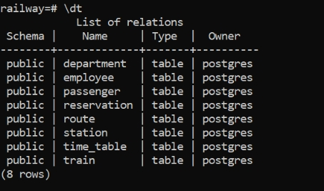

>>>>>>>>>>>>>>>>>>>>INSERT VALUES (Each table 8 values) <<<<<<<<<<<<<<<<<<<

INSERT INTO

Train ( train_no , tname , total_seats , available_seats )

VALUES

( 1 , 'Amaravati Express' , 500 , 500 ),

( 2 , 'Anga Express' , 500 , 500 ),

( 3 , 'Bangalore Rajdhani Express' , 1000 , 1000 ),

( 4 , 'Bhagmati Express' , 500 , 500 ),

( 5 , 'Brindavan Express' , 500 , 500 ),

( 6 , 'Chamundi Express' , 400 , 400 ),

( 7 , 'Goa Express' , 800 , 800 ),

( 8 , 'Kaveri Expresss' , 500 , 500 );

INSERT INTO

Employee ( eid , fname , lname , salary , phone_no , gender , address , dob)

VALUES

( 1 , 'Aryan' , 'Gupta' , 30000 , '9987567823' , 'male' , 'RR Nagar , Bengaluru' , '1996-12-02' ),

( 2 , 'Raju' , 'Kumar' , 30000 , '9984567433' , 'male' , 'EC city , Bengaluru' , '1994-01-04' ),

( 3 , 'Nikhil' , 'Aggarwal' , 60000 , '9187557521' , 'male' , 'Anekal , Bengaluru' , '1994-11-12' ),

( 4 , 'Anshul' , 'Aggarwal' , 40000 , '9987777823' , 'male' , 'Banashankari , Bengaluru' , '1990-12-02' ),

( 5 , 'Gagan' , 'Gowda' , 60000 , '9087567873' , 'male' , 'RT Nagar , Bengaluru' , '1998-09-09' ),

( 6 , 'Vijay' , 'Kumar' , 20000 , '9987457823' , 'male' , 'RR Nagar , Bengaluru' , '1980-11-06' ),

( 7 , 'Pavithra' , 'Gowda' , 34000 , '9987545872' , 'female' , 'Varthur , Bengaluru' , '1985-10-05' ),

( 8 , 'Mohammad' , 'Nazir' , 30000 , '8187565623' , 'male' , 'Shivaji Nagar , Bengaluru' , '1989-02-04' );

INSERT INTO

Passenger ( pid , fname , lname , phone_no , gender , address , dob)

VALUES

( 1 , 'Shuan' , 'Gupta' , '9987567823' , 'male' , 'RR Nagar , Bengaluru' , '1996-12-02' ),

( 2 , 'Raj' , 'Kumar' , '9984567433' , 'male' , 'EC city , Bengaluru' , '1994-01-04' ),

( 3 , 'Nikhil' , 'Gowda' , '9187557521' , 'male' , 'Anekal , Bengaluru' , '1994-11-12' ),

( 4 , 'Anurag' , 'Kashyap' , '9987777823' , 'male' , 'Banashankari , Bengaluru' , '1990-12-02' ),

( 5 , 'Gagan' , 'Gowda' , '9087567873' , 'male' , 'RT Nagar , Bengaluru' , '1998-09-09' ),

( 6 , 'Vijay' , 'Kumar' , '9987457823' , 'male' , 'RR Nagar , Bengaluru' , '1980-11-06' ),

( 7 , 'Sonu' , 'Gowda' , '9987545872' , 'female' , 'Varthur , Bengaluru' , '1985-10-05' ),

( 8 , 'Umar' , 'Khan' , '8187565623' , 'male' , 'Shivaji Nagar , Bengaluru' , '1989-02-04' );

INSERT INTO

Reservation ( seat_no , ticket_price , pid , train_no)

VALUES

(23 , 150 , 1 , 8),

(34 , 150 , 2 , 2),

(45 , 150 , 3 , 6),

(32 , 150 , 4 , 5),

(67 , 150 , 5 , 3),

(87 , 150 , 6 , 1),

(34 , 150 , 7 , 9),

(200 , 150 , 8 , 4);

INSERT INTO

Department ( dno , dname , no_of_employees)

VALUES

(1 , 'Reservation' , 30),

(2 , 'Cleaning' , 80),

(3 , 'Mantainence' , 40),

(4 , 'Engineering' , 90),

(5 , 'Hardware' , 100),

(6 , 'Electrical Engineering' , 30),

(7 , 'Operating and Traffic' , 50),

(8 , 'Security' , 70);

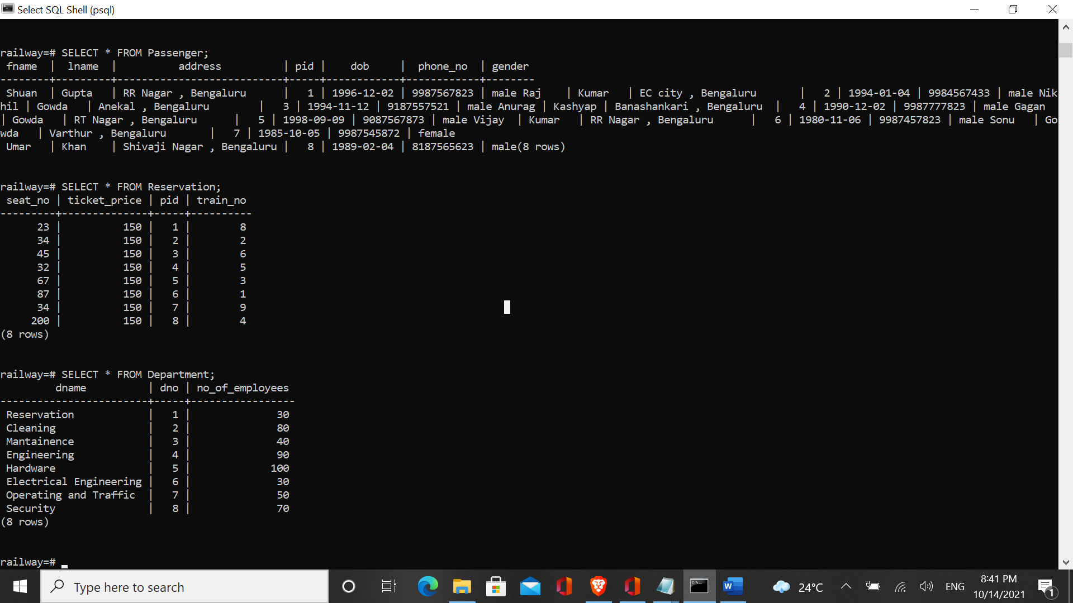

INSERT INTO

Station ( sno , sname , district , state , pincode)

VALUES

( 1 , 'Bangalore City Railway Station' , 'Bengaluru' , 'Karnataka' , 560001 ),

( 2 , 'Yesvantpur Railway Station' , 'Bengaluru' , 'Karnataka' , 560041 ),

( 3 , 'Krishnarajapuram Railway Station' , 'Bengaluru' , 'Karnataka' , 560089 ),

( 4 , 'Agumbe Railway Station' , 'Shivmoga' , 'Karnataka' , 577411 ),

( 5 , 'Yedur Railway Station' , 'Shivmoga' , 'Karnataka' , 577277 ),

( 6 , 'Bijapur Railway Station' , 'Bijapur' , 'Karnataka' , 586104 ),

( 7 , 'Dharwad Railway Station' , 'Dharwad' , 'Karnataka' , 590002 ),

( 8 , 'Anekal Railway Station' , 'Bengaluru' , 'Karnataka' , 560056 );

INSERT INTO

Route ( source , destination)

VALUES

('Bengaluru' , 'Mysore'),

('Bengaluru' , 'Goa'),

('Mysore' , 'Chennai'),

('Bengaluru' , 'Tirupati'),

('Bengaluru' , 'Bellari'),

('Mysore' , 'Manglore'),

('Bengaluru' , 'Kochi'),

('Bengaluru' , 'Shivmoga');

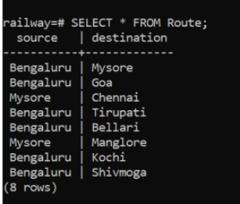

INSERT INTO

Time_Table ( arrival_time , departure_time , train_no )

VALUES

('09:00:00', '18:00:00' , 1),

('10:00:00', '19:00:00' , 2),

('09:00:00', '18:00:00' , 3),

('11:00:00', '20:00:00' , 4),

('10:00:00', '19:00:00' , 5),

('03:00:00', '18:00:00' , 6),

('10:00:00', '12:00:00' , 7),

('06:00:00', '18:00:00' , 8);

**TEAM CONTRIBUTION**:

• Balendra D P:- Create commands and Documentation screenshots(3hrs)

• Balaji B V:- Intent of information and Insert commands (3hr)

• Bharat Kumar Naik:- Task1 and Insert commands (3hrs)